**Active Learning for Computer Vision Curriculum**

**Project 5 Solution: Pool-based Active Learning – Part 3**

**Total Points Possible: 50**

**Problem 1 (50 points)**

Sample outputs are shown below. The correct answers should resemble these output.

**Note**: these graphs are from the paper by Chakraborty et al. (discussed in the lecture material). The outputs may differ slightly and may not exactly match these outputs, based on implementation sepcifics. These should just be used as references.

i)

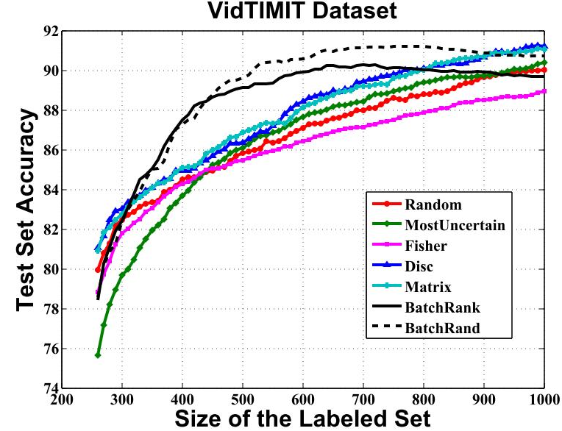

ii)

